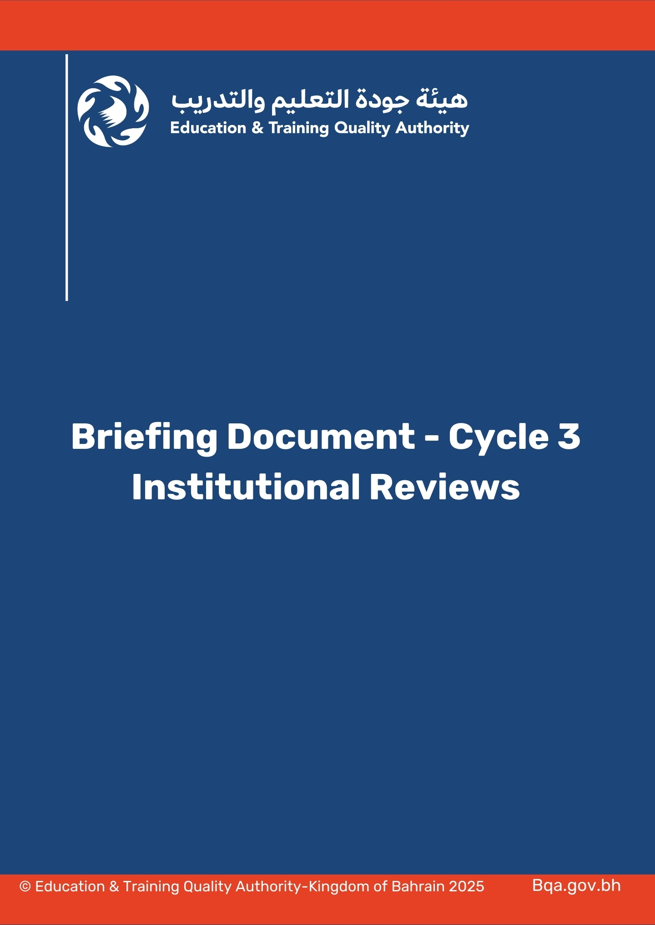

**Briefing Document**

**Cycle 3 Institutional Reviews**

**Background**

The Education & Training Quality Authority (BQA) is mandated to “review the quality of the performance of education and training institutions in light of the guiding indicators developed by the Authority” (Royal Decree No 83 of 2012). In keeping with this mandate, the Directorate of Higher Education Reviews (DHR) of the BQA is reviewing the higher education institutions operating in the Kingdom of Bahrain and have a physical presence in the country.

BQA Institutional Reviews are carried out using the nine Standards listed in the General Framework of Higher Education Institutional Reviews, which was approved by the Cabinet of Ministers on the 3rd of April 2023 and published on the 7th of August 2023 as per the Cabinet’s Resolution No. 55 of 2023.

The institutions that receive a “Compliant” Judgement in the Institutional Reviews conducted by the BQA, will be eligible to apply for Institutional Accreditation from the Higher Education Council (HEC). These Institutions will be also listed or remain listed on the National Qualifications Framework (NQF) Register. The Institutions that receive a “Partially Compliant” Judgement will be subject to an extension visit in less than two years after the institution and the concerned entities are notified with the initial review judgement. A “Partially Compliant” Judgement in the Institutional Review is not considered as a final judgement and the outcomes of the Extension Visit may lead to either “Compliant” or “Not Compliant” Judgement. The Institutions that receive a “Not Compliant” Judgement will be Rereviewed by the BQA after one year from the publication date of the institutional review report. The Rereview will also lead to either “Compliant” or “Not Compliant” Judgment.

On (**day month year),** **the HEI** submitted its Self-Evaluation Report and supporting materials. These documents will be studied by a Panel, representing the BQA, which will conduct a site visit at the **HEI**. The visit will be held from (**day month year)**, and will involve interviews with senior management, faculty members, students and other stakeholders selected by the Panel.

The Panel thanks those persons who will be giving their time to assist **HEI** and the DHR in this valuable process.

**Why are Interviews Being Conducted?**

The interviews are being conducted to explore and test the claims made in the Self-Evaluation Report prepared by **HEI.** This process is known as ‘triangulation’, that is, gathering evidence about one subject through several different methods. Site visit with interviews are common features of external review/audits.

**The Interview Sessions**

A number of interview sessions will be held over **four** days. Some interviews will be between the Panel and an individual, while others will involve a group.

The Panel will have some specific questions to ask, and therefore there will not usually be time for more free-ranging discussion.

The Panel does not investigate individual complaints from students or staff.

**Ground Rules for Interview Sessions at the Site Visit**

The interviews are **confidential**. Anything said by any person being interviewed will be treated as ‘in confidence’ by the Panel and not revealed to anyone else.

The President/Chief Executive of the institution shall ask all persons being interviewed to speak freely and honestly to the Panel.

Persons who are interviewed are asked not to talk about the detailed content of their interview or to take any notes of the interview session.

Interviews will keep strictly to time.

Persons who are to be interviewed must assemble at the place designated by the institution 15 minutes before their scheduled interview time.

Latecomers will not be admitted to interviews.

Mobile phones must be switched off or set to ‘silent’.

As the time for each interview session is limited, there will be no introductions. There is no handshaking. The Chair of the Panel will give a brief greeting.

Persons being interviewed are asked to bring their name plates with them and take a seat immediately on the side opposite the Panel, placing their name plates before them. People should take away their own name plates when the session finishes.

In a group interview, each question is usually asked of a different person. The interviewees should respond directly and briefly to the questions as the time is limited.

Persons being interviewed should ask for the question to be repeated in English or in Arabic if they do not understand it.

No papers/documents are to be given to the Panel during an interview session. Any documents should be given to the Director responsible for co-ordinating the site visit.

**Who will conduct the Interviews at the Site Visit?**

The Site Visit interviews are being conducted by an independent expert Panel constituted by the DHR. All Panel members have signed a declaration of confidentiality, and the institution has confirmed that they have no conflict of interest.

**What Will Happen After the Site Visit?**

After the site visit, the Panel will submit to the DHR the Review Report that will state the findings of the Panel.

The institutionwill have an opportunity to comment on matters of fact or emphasis in the Review Report before it is finalised.

The Review Report will serve at a meeting of the BQA Board. After being approved by the Board and endorsed by Cabinet, the Report will be published.