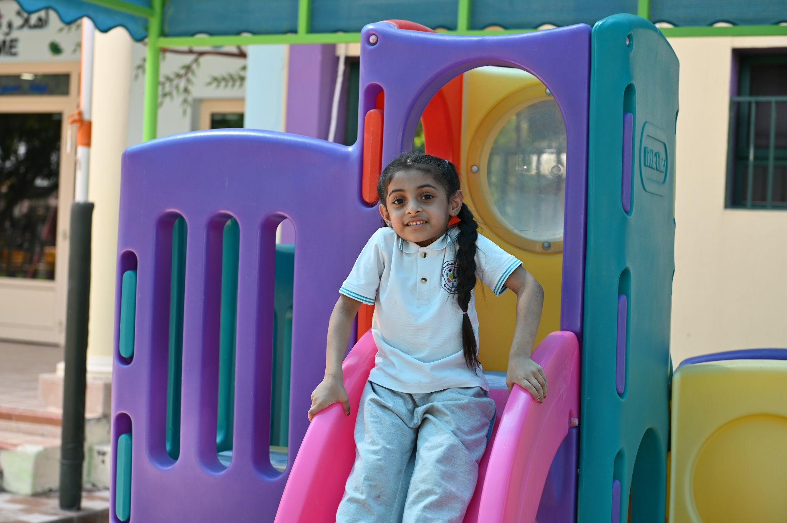

**Self-Evaluation Form (SEF)**

For use in Kindergartens Reviews in the Kingdom of Bahrain



**Introduction**

**This Self-Evaluation Form (SEF) is designed to:**

* provide a format to help the kindergarten record the outcomes of its self-evaluation
* provide the review team with a summary of the kindergarten’s evaluation of its work

**The Self-Evaluation Form (SEF) consists of two parts:**

**Part A:** includes factual information about the kindergarten, enrolled children and staff, which should be as up-to-date as possible.

**Part B:** corresponds with the sections of the Review Framework. The kindergarten is required to evaluate its work and record its main strengths and areas for development in each aspect of the framework.

The **‘Kindergarten Review Handbook’** includes an interpretation of these aspects, criteria and indicators, which reviewers will be evaluating during the review to finally conclude recommendations.

**Importance of Self-Evaluation and SEF in Kindergarten Review:**

1. The SEF should provide an objective and accurate reflection of the kindergarten's performance.
2. The SEF should clearly outline the kindergarten’s strengths and areas for further development.
3. While completing the SEF, it's important to summarise the most important evidence rather than include all practices in full detail.

**Part A: Information about the kindergarten, staff and children**

The purpose of this part of the SEF is to bring together the key information that the team needs to plan for the review successfully. The information is needed to understand the kindergarten’s characteristics and provision including the curriculum it offers, as well as distinctive features and any factors that may impact performance.

|  |
| --- |
| **Information about the kindergarten** |
| **Name of the kindergarten (Arabic)** |  | | |
| **Name of the kindergarten (English)** |  | | |
| **Year of establishment** |  | | |
| **Address** | **Building** | **Road** | **Block** |
|  |  |  |
| **Location** |  | | |
| **Governorate** |  | | |
| **Kindergarten’s telephones** |  | | |
| **Kindergarten’s e-mail** |  | | |
| **Kindergarten’s website**  **-if applicable-** |  | | |
| **Implemented Curriculum/ experiences** |  | | |
| **Main language(s) of instruction** |  | | |

|  |
| --- |
| **Information about Kindergarten staff** |
| **Position** | **Name** | **Tenure in Kindergarten** | **Contact number** | |
| **Kindergarten’s Principal** |  |  |  | |
| **Assistant Principal** |  |  | |  |
| **Number of teaching staff** |  | | | |
| **Number of practitioners** |  | | | |
| **Number of teaching assistants -if any-** |  | | | |

|  |
| --- |
| **Information about the children** |
| **Total number of children** |  | | | |
| **Number of boys** |  | | | |
| **Number of girls** |  | | | |
| **Kindergarten’s levels**  **(e.g. Age 4-5/ KG1/ 2 classes)** | **Age** |  |  |  |
| **Level** |  |  |  |
| **No. Classes** |  |  |  |
| **Number of Bahraini children** |  | | | |

###### Positives, constraints and priorities

## This part will provide the kindergarten the opportunity to highlight features that aid or inhibit its performance (for instance changes in management, number of classes, etc).

|  |
| --- |
| **Key positives** |
|  |

|  |
| --- |
| **Constraints** |
|  |

|  |
| --- |
| **Priorities** |
|  |

###### Part B: Kindergarten’s Self-Evaluation

### To help focus your evaluation in this section, consider writing about the aspects’ criteria and indicators as outlined in the ‘Kindergartens Reviews Handbook’.

**The kindergarten evaluates the quality of aspects as follows:**

|  |
| --- |
| **Aspect 1: Children's Growth and Development** |
| **Positive features (with examples)** |
|  |
| **Areas for development (with examples)** |
|  |

|  |
| --- |
| **Aspect 2: Child Initiated Learning** |
| **Positive features (with examples)** |
|  |
| **Areas for development (with examples)** |
|  |

|  |
| --- |
| **Aspect 3: Leadership and Management** |
| **Positive features (with examples)** |
|  |
| **Areas for development (with examples)** |
|  |